|  |  |  |  |  |  |
| --- | --- | --- | --- | --- | --- |
| Date | 23-Nov-22 | | | Tester Name | Richard Belanger |
| Environment | Penfax - Test | | | Login used | TEST2 |
| Operating System | Windows | Version: | Update: | | |
| Software Used | Edge | Version: | Update: | | |
| Not Applicable | Version: | Update: | | |
| Release version | 22.4.1 | | | | |
| Title | M2.14 enter notes in different screen and see if they carry over to main note screen  M2.15 Delete a note  M2.16 Edit a note  M2.17 Add multiple notes  M2.18 check audit does name of user show up as entering notes | | | | |
| Test Type | Regression | | | | |
| Test Scenario | Enter notes in PENFAX to reflect above scenarios | | | | |
|  |  | | | | |
| Expected Results | Notes will be correct by scenario and will be seen in Person Profile- main note screen | | | | |
| Pass/Fail | Pass | | | JIRA# | N/A |

Describe your steps with screenshots:

**M2.14** enter notes in different screen and see if they carry over to main note screen(Person Profile)

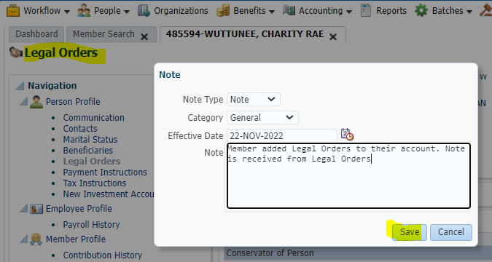

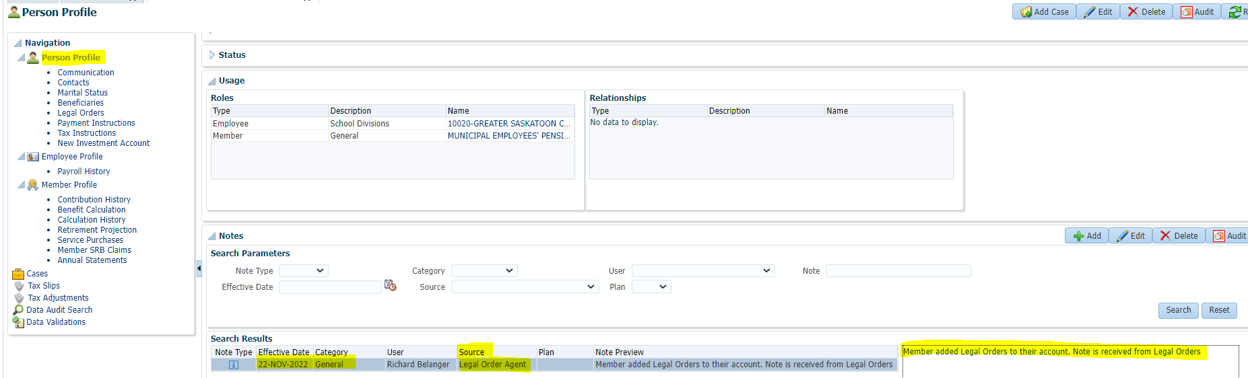

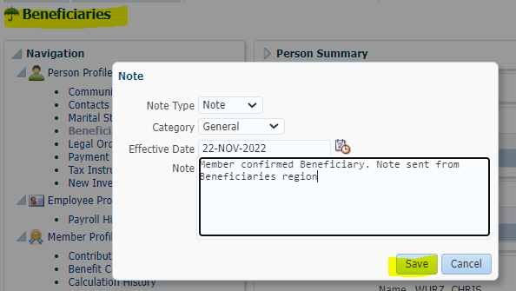

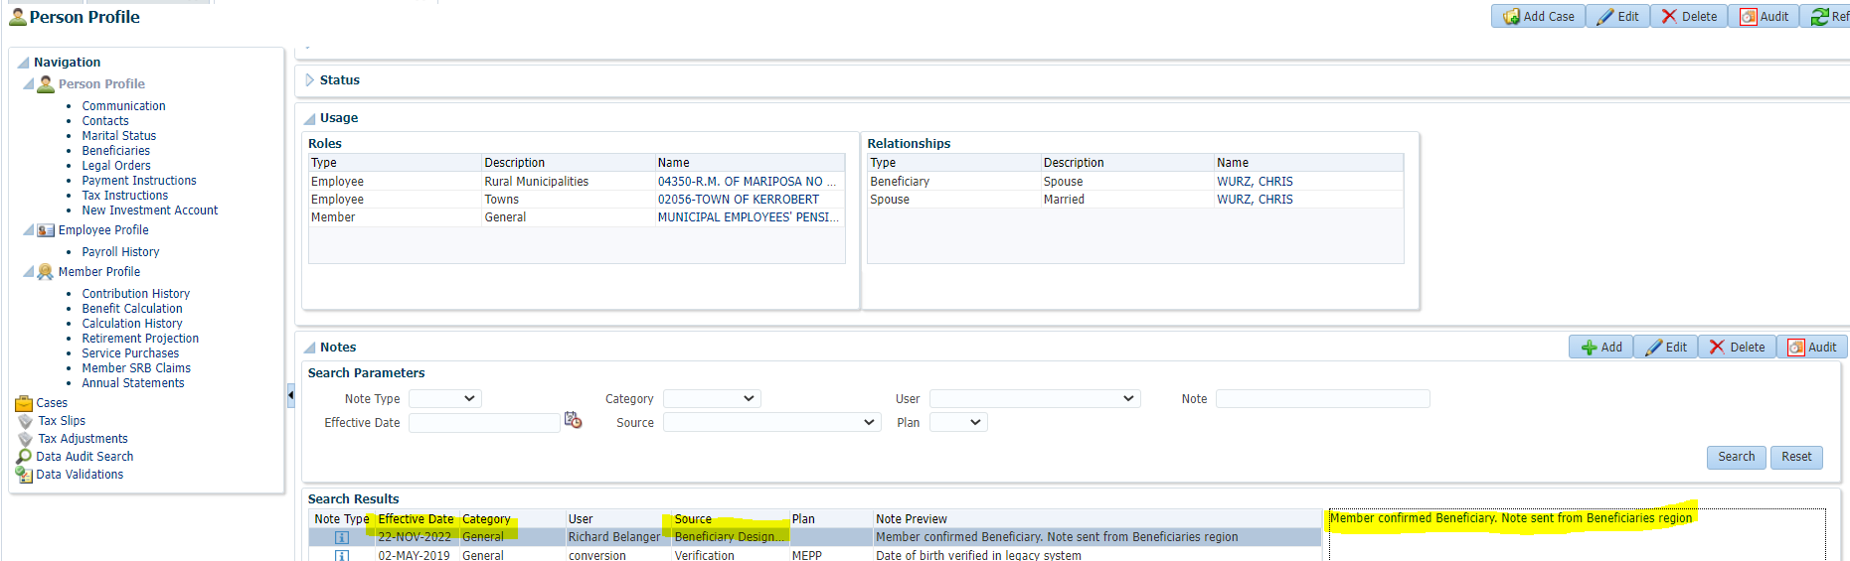

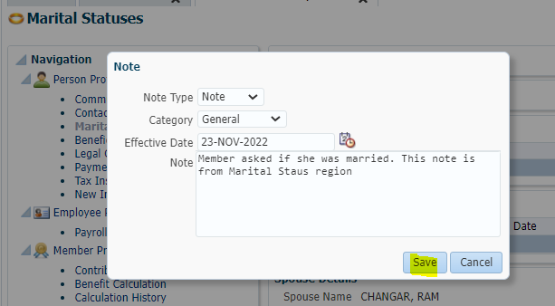

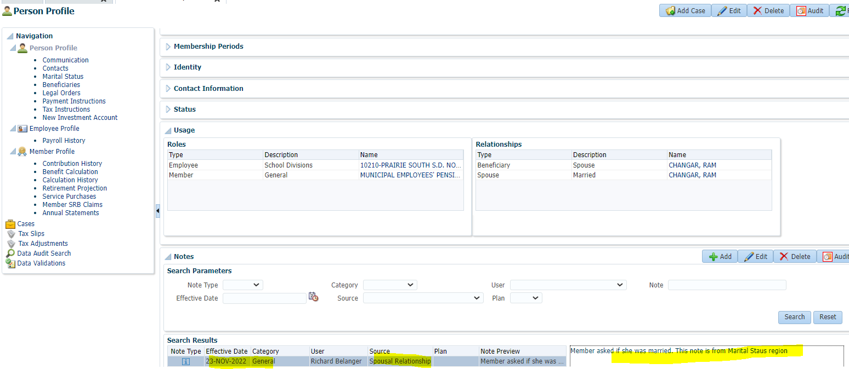

**M2.15** Delete a note

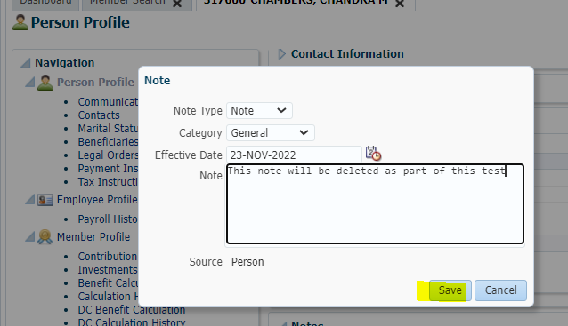

View the note saved then delete

Note saved rolled up to Person Profile(main screen)>Delete the note

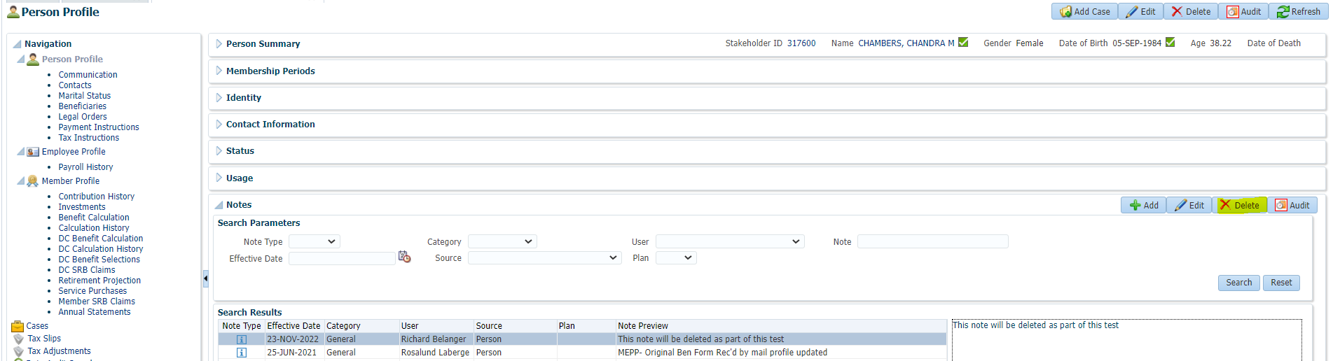

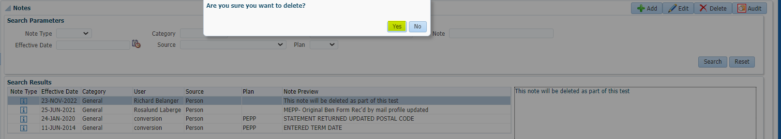

Note has been deleted

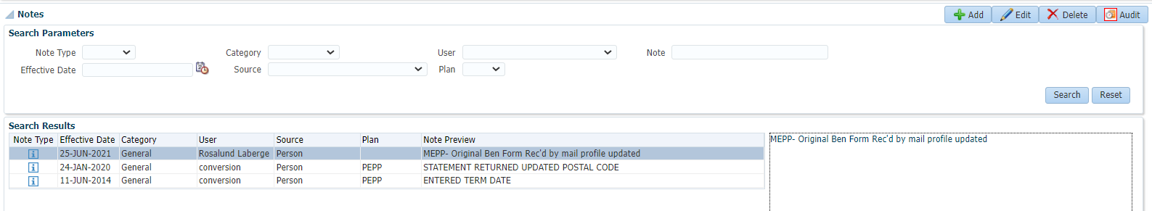

**M2.16** Edit a note

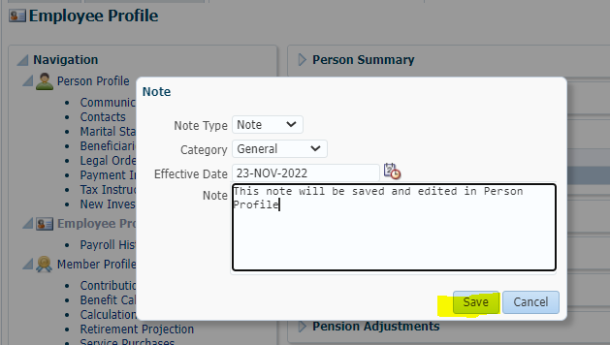

Edit the note from Person Profile

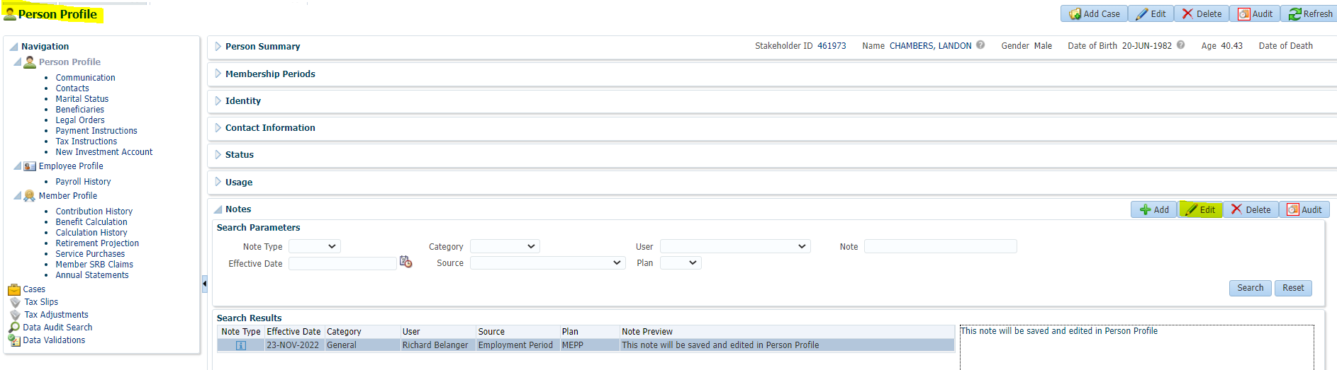

Edited note

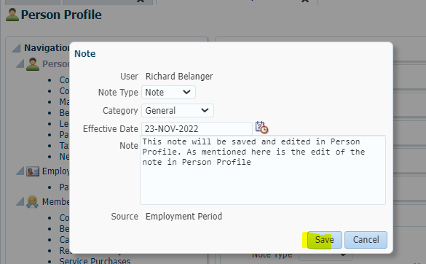

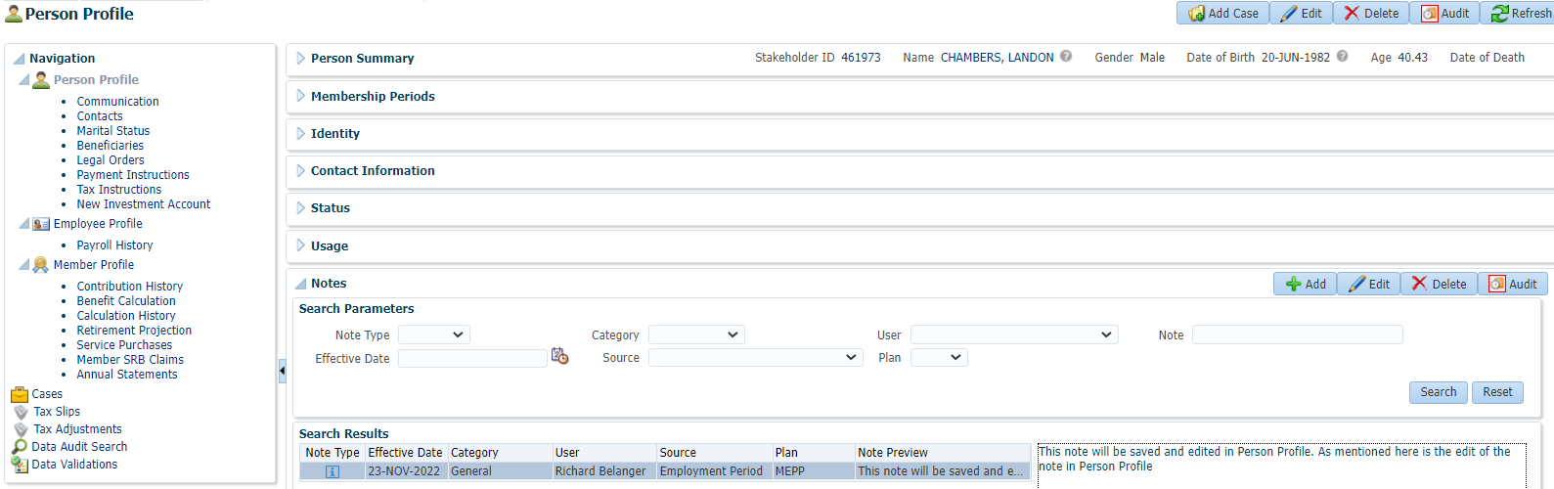

**M2.17** Add multiple notes

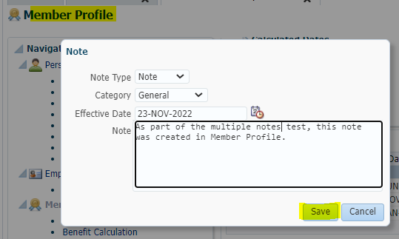

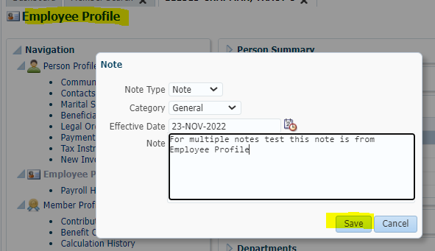

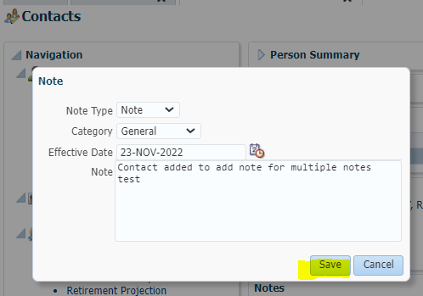

View the three saved notes in Person Profile

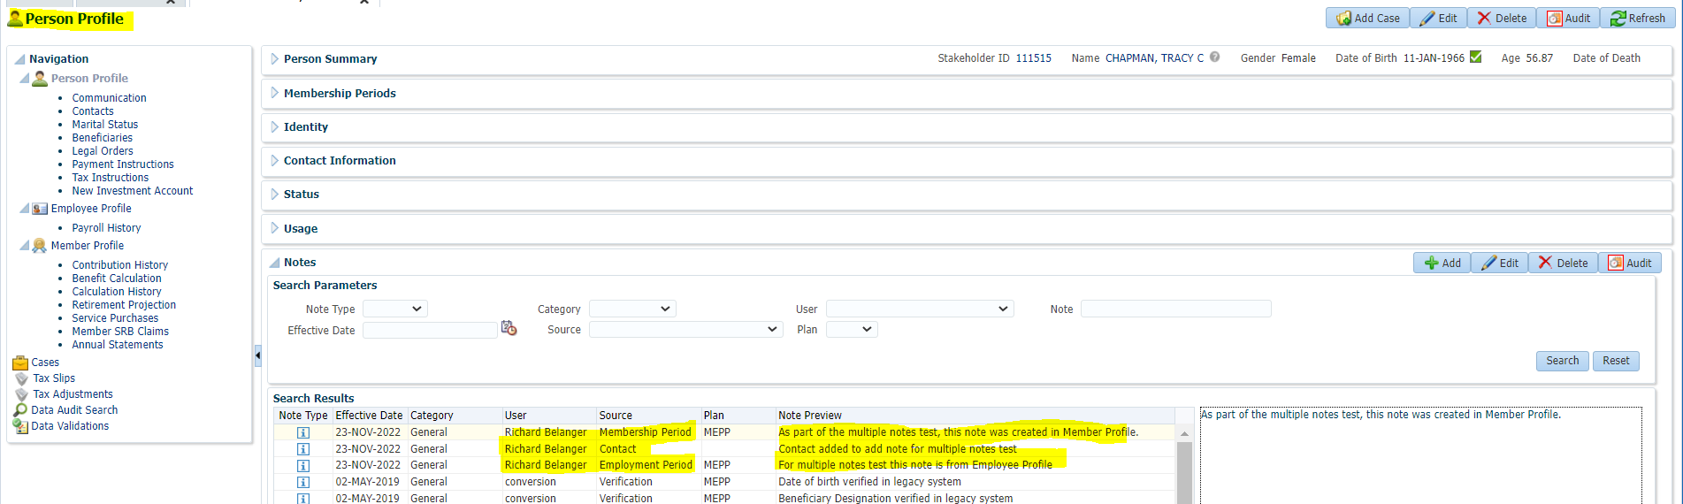

**M2.18** check audit does name of user show up as entering notes

